|  |  |
| --- | --- |
|  | **Available online at** <https://ojs.umrah.ac.id/index.php/kemudi>  Volume: 8 (2) Issue: 26 Febuary 2024  **KEMUDI: JOURNAL OF GOVERNMENT SCIENCE ISSN (Online): 2622 9633, ISSN (Print): 2528 5580** |

Strategic Steps to Ward Off Negative Potential During Digital Campaigns Ahead of The Indonesian General Election in 2024

M. Ferdi Septianda1, Deni Kurniawan2

1 Government Science program of Social and Political Sciences, Universitas Maritim Raja Ali Haji, Indonesia

2 Government Science program of Social and Political Sciences, Universitas Maritim Raja Ali Haji, Indonesia

*Corresponding Author:* [mferdiseptianda@gmail.com](mailto:mferdiseptianda@gmail.com)

|  |  |
| --- | --- |
| **Article Info** |  |
| **Keyword:**  *ward off; negative potential; digital campaigns; general elections* | **Abstract**: *Political activities such as general election campaigns in Indonesia have been elaborated on a digital basis. Digital election campaigns place the public as sources or intermediaries, in contrast to campaigns before the digital era which only placed the public as consumers or recipients. Through social media, people are free to support the candidates they want to elect. On the one hand, digital election campaigns are often used as a tool to bring down political opponents in unhealthy ways because, through social media, people are easily propagated so digital election campaigns have the potential to be filled with hoaxes, hate speech, and black campaigns. This research aims to look for strategic steps that can be taken by the government and society so that the digital campaign ahead of the 2024 elections in Indonesia is not filled with hoaxes, hate speech, and black campaigns. This research is qualitative research in the nature of a literature study to collect information relevant to the topic of discussion. The data sources used come from reference books and scientific articles. Before finding strategic steps to counteract the negative potential of digital campaigns ahead of the election, researchers first look for and analyze the factors that underlie the negative potential of digital campaigns ahead of the election. The research results show that four factors underlie the emergence of negative potential for digital campaigns ahead of the election, including ambition for power, political polarization, societal and cultural factors, and digital literacy factors. These factors were analyzed, resulting in four strategic steps that could be taken to counteract the negative potential of digital campaigns ahead of the elections in Indonesia in 2024. First, public education. second, increasing digital literacy. third, supervision and law enforcement. fourth, cooperation between institutions.* |
|  |  |
| **Article History:** Received 28-12-2023, Revised 02-01-2024, Accepted: 26-01-2024 | |
| **How to Cite:** Septianda & Kurniawan (2024). Strategic steps to ward off negative potential during digital campaigns ahead of the Indonesian general election in 2024. KEMUDI: Journal of Government Science, 8 (02), 57-72 | |
|  | |

**INTRODUCTION**

Globalization has a big impact on activities in Indonesia and indirectly leads society to changes in various areas of life. People living in the era of globalization certainly feel both positive and negative impacts. Gradually, globalization removes barriers or boundaries that were previously limited in national reach, such as internationalization, liberalization, universalization, de-territorialization, and westernization (Saodah et al., 2020). In line with that, globalization has erased the boundaries of each country both economically, socially, and politically (Widiyono, 2019). As a result, life which is wrapped in traditional aspects and tends to be oriented towards norms and local aspects of culture is increasingly being eroded, it is very easy for people to find other alternatives to speed up all their activities. This is caused by society's view of being focused on practical ways to make work easier amidst the complexity of life, or in other words, there has been a massive modernization process that has changed human thinking patterns.

Modernization as one manifestation of globalization grows through an interactive and diverse process of information dissemination. Information is a very influential element in changing human thought patterns in the era of globalization (Nahak, 2019). In globalization, the massive dissemination or distribution of information does not stand alone but is supported by the help of digital media and digital technology, so the term "digital era" appears. All countries in the world compete with each other in efforts to increase the efficiency of human activities with the help of digitalization (Fadhilah et al., 2021).

Digital media is equipment in the form of gadgets, personal digital assistants, computers, and the Internet. There are four main classifications of digital media, namely communication media between individuals such as email and Gmail, media for gathering information such as Google, multi-directional game media such as online games, and participatory media such as online chatting (Kurniasih, 2019). In Indonesia itself, various digital media have entered and there are four main classifications of digital media, both those originating from abroad and domestic production. All countries are competing to create various digital media to meet needs, increase existence, and increase competitiveness. Apart from digital media, the dissemination of information related to modernization as a manifestation of globalization is also through digital technology.

Digital technology has entered various areas of life such as health, transportation, the economy, and others (Putra, 2018). Digital technology has an addictive effect on children and parents because digital technology is often used as a primary need and humans are very dependent on the facilities available therein (Danuri, 2019). Various digital technology products have emerged, the latest of which is artificial intelligence technology or what is usually called Artificial Intelligence (AI). The dissemination of information related to modernization as a manifestation of globalization supported by digital media and digital technology has brought society into the digital era.

People in the digital era are individuals who are faced with things available on gadgets in the form of entertainment, videos, images, articles, and information (Siahaan, 2018). People freely search for information about whatever they like and are trending (Gunawan, 2021). This digital era has brought changes to the order of human life and the order of national and state life. Political activities or agendas related to general elections (Pemilu) in a region to elect leaders now involve digitalization as a campaign medium for self-promotion.

The election campaign was initially based on a traditional basis which lasted for years with campaign props as regulated in Article 32 paragraph 2 of General Election Commission Regulation Number 33 of 2018 such as billboards, billboards or videotrons, banners, and banners. The props mentioned are still maintained and used today. However, in this digital era election campaigns have been elaborated with digital-based concepts utilizing social media as a political communication medium wrapped in a variety of content. Until now, campaigns are still synonymous with money political campaigns, musical performances, posters, and large billboards in urban corners, but will slowly change to digital campaigns which are considered more effective in increasing electability and popularity (Boestam et al., 2023). This was done because we saw that the number of social media users and internet users in Indonesia experienced an increase every year.

At the beginning of 2022, the number of internet users in Indonesia will be around 204.7 million, which means an increase of 2.1 million from the previous year. Apart from that, the number of social media users in Indonesia is very high, around 191.4 million people, which means it is equivalent to 68.9 percent of the total population in Indonesia (Susanti et al., 2023). The increase in the number of social media and internet users in Indonesia has brought about huge changes regarding the implementation of election campaigns in this digital era. In the pre-digital era, each actor was interconnected with each other and had their position. the position of politicians as sources, journalists as communicators or intermediaries, and the position of society as consumers or recipients. However, in the digital era, these characteristics no longer apply, people are not only in the position of recipients but also sources and intermediaries (Wiguna, 2017).

The digital era in Indonesia has produced dynamics of benefits and challenges and has had both positive and negative impacts. such as the digital era campaign phenomenon which places the community as a source and intermediary. On the one hand, this creates free space for society to choose leaders who are deemed worthy and have capability, compatibility, and acceptability. The public can easily get information and track records related to leadership through internet access and social media such as YouTube, Instagram, x, TikTok, Facebook, etc. Apart from that, social media is a place for candidates to introduce themselves and build trust in the public to get votes. Social media is a place to implement political branding by using content to get public attention (Abidin & Cindoswari, 2019). Furthermore, social media has become a place for candidates who have just participated in election contests and candidates who have experience building a personal branding image (Mulyani, 2021).

These are just a few of the advantages or positive impacts of digital campaigns via internet access or social media, beneficial for the public and candidates. On the other hand, internet access and social media create challenges and negative impacts such as the emergence of hoaxes and hate speech. Hoaxes and hate speech often emerge when Indonesia is in political momentum, people will blame each other and be suspicious of each other when the general election takes place (Irhamdhika, 2022). Approaching the election, fake news (hoaxes), and hate speech are problems that have great potential to worsen the atmosphere in society. This digital era makes hoaxes and hate speech very easy to create and spread quickly (Diniyanto & Sutrisno, 2022). Every day Indonesian people receive 91.80% of the political sector and 88.60% of hoaxes contain Sara. The facts show that 92.40% of hoaxes are disseminated through social media (Fensi, 2018).

This digital campaign activity does not only involve the candidate himself, but the support base from various groups as well as supporting political parties and coalition political parties. The dream of winning the election will be the main focus which will be carried out in various ways and it may be done in ways that conflict with the rules, including the use of political buzzers. Political buzzers are one of the pillars of success for a candidate for leadership of a region or country during the election period, because political buzzers are not only limited to doing political marketing but also bringing down and making fun of other candidate pairs (Juditha, 2019).

Hoaxes and hate speech will certainly become a concern for the general public in the 2024 elections, and a number of issues will circulate wildly to divide Indonesian society. Digital campaigns carried out by candidates contesting general elections are not just a way to promote themselves and gain public votes. However, it will be used as a communication medium to provide or seek sponsorship from outside political parties so that the campaign activities carried out can be more effective so that the number of sympathizers increases. More than that, digital campaigns via social media have the potential to be misused and become a cover for black campaign activities or what is usually called a black campaign.

Black campaigns are carried out to bring down political opponents (Doly, 2020). Approaching the 2024 election, we have seen indications of a black campaign expressed in a series of issues containing slander, insults, and bullying aimed at bringing down the candidates. Apart from being detrimental to the candidates competing in the 2024 general election, this black campaign is very detrimental to the Indonesian people because black campaigns can change people's perception of a candidate. Indirectly, people are led to vote for candidates who are not produced through a true democratic process. To overcome hoaxes, hate speech, and black campaigns, the Indonesian government has made several laws and regulations so that all elements of society are wiser in their actions and to provide a deterrent effect for perpetrators of hoaxes, hate speech, and black campaigns.

Article 45 paragraph 1 and paragraph 2 of the Information and Electronic Transactions Law or the ITE Law (UU ITE) has emphasized sanctions for perpetrators of hoaxes, hate speech, and black campaigns. However, this law is often considered to conflict with freedom of expression, so its implementation has not been optimal. The ITE Law is often perceived by the public as a tool to silence freedom of expression on the Internet (Wahyu Permadi & Bahri, 2022).

Therefore, effective strategic steps are needed to ensure that digital campaigns ahead of the general election in Indonesia in 2024 are free from fake news (hoaxes), hate speech, and black campaigns. Apart from that, these strategic steps are needed to avoid conflicts and disputes in society, both pre and post-election in 2024. This article will review and find strategic steps that can be taken jointly by the Government of the Republic of Indonesia and the Indonesian people to counter the potential negative potential during the digital campaign ahead of the 2024 election. Before we get to that section, we will first explain the factors that underlie the negative potential of digital campaigns ahead of the election.

**RESEARCH METHOD**

Research methods are needed to get answers that are relevant to the problem being researched. The research method used in this research is qualitative like library research. Qualitative research is a scientific study that is rooted in an inductive mindset which refers to in-depth observation of a phenomenon (Harahap, 2020). Qualitative research is dominantly oriented toward comprehensive or holistic descriptions that can explain in full activities or situations that are occurring rather than comparing the effects of certain treatments or explaining someone's attitudes or behavior (Adlini et al., 2022). Then, a literature study is an attempt to collect information that is appropriate to the topic being discussed. The data sources used in qualitative research are literature studies, coming from reference books and scientific articles (Tahmidaten & Krismanto, 2020). In conducting qualitative library research, several procedures must be carried out, namely: 1) Tracing primary and secondary data sources, 2) Classification based on research formulas, 3) data processing or citing references, 4) displaying data, 5) data abstraction, 6 ) data interpretation, 7) conclusions (Darmalaksana, 2020).

**RESULTS AND DISCUSSION**

**Factors underlying the emergence of negative potential during digital campaigns ahead of the Indonesian general election**

1. **Power Ambition Factor**

Ambition for power is the desire to gain and maintain political power through elections (Naomi & Muhyidin, 2021). The fundamental factor in an ambition for power according to (Haquri & Sahab, 2023) is that each candidate in an election has the desire to nominate himself in the election to influence policy and become a driver of change according to psychological tendencies. Ambition in the election is very large, various methods are used by individual candidates and groups to obtain votes in the election.

The main goal of candidates to win elections is to rule in government, both legislative and executive institutions. There are many efforts made by candidates to get the votes of election participants, ranging from legal methods to illegal methods. In the practice of invisible power, political elites use religious and customary issues as a propaganda effort to seek votes in power, because religious values ​​and local traditions of society are strong factors in "deceiving" residents in the area (Andi Muh. Dzul Fadli, Indrawan Tobarasi, 2018). Recently, the strongest issue of identity politics has been using religious issues which are disseminated via social media. Compiled from the CNN Indonesia website, Ganjar Pranowo's call to prayer on private television stations has been widely associated with identity politics (Thr/bmw, 2023).

1. **Political Polarization Factors**

People who have different views on a candidate will enter into political polarization. Political polarization is a popular event that predominantly grows at the mass level rather than at the level of political leaders so that a group feels that only its views and principles are correct (Annas et al., 2019). All democratic countries will experience political polarization as elections approach, this is based on the principle of respecting opinions and differences as well as freedom to make choices. This is very normal, as long as it doesn't cross the threshold. However, political polarization is very dangerous because it is caused by statements and opinions expressed by candidate supporters that attack personal aspects rather than criticizing the program plans of political parties and candidates (Fathurochman & Tutiasri, 2023).

Election contests in Indonesia are certainly filled with candidates with different backgrounds and ideas. In general, the ideas brought by a candidate will include pluralism as the main concept so that ideas can reach all groups. On the one hand, the ideas conveyed often focus on one entity that is important in life, such as religion. Ideas that carry the theme of pluralism and religion want to create an ecosystem containing people who are ready to support the political maneuvers of a candidate. Ideas on the themes of pluralism and religion give rise to diverse political dynamics, which play a major role in influencing participation and democracy in Indonesia. However, groups that carry the theme of pluralism can cause disputes, creating controversy between religious and pluralist groups (Angretnowati & Karolus, 2022).

The resulting controversy pits religious and pluralist groups against each other and polarizes politics to defend arguments. Political polarization gives rise to political beliefs that are difficult to change and creates intolerance toward views that are considered contradictory (Fernando et al., 2022). The pluralist group uses the term "Islamist" to apply to groups whose religious views are doctrinaire and conservative. The pluralist group views that this group will try to strengthen the influence of Islam in government and society so that it can disrupt harmony and trust in society by promoting religious exclusivity (Mansyur, 2023).

1. **Community and Cultural Factors**

Globalization has changed many things related to cultural aspects, such as bringing people into acculturation with foreign cultures, but has not eliminated cultural values ​​related to the social sphere, such as solidarity and coming together to provide support. Globalization provides an alternative regarding this matter so that it can be done effectively, efficiently, and able to reach many parties. However, when approaching political activities such as elections, this is often used by irresponsible parties to create a negative culture. The negative culture referred to is people's habits of perpetuating negative things, condoning or participating in supporting the negative potential of digital campaigns ahead of elections such as hoaxes, hate speech, and black campaigns.

During the current campaign period, people often don't care about the source of the news, quite a few of the news circulating on social media are hoaxes, resulting in unrest and quarrels in the community. Oftentimes, the presence of hoax news cannot be separated from mere rumors, where these issues sometimes develop and are created to lead to opinions by one party. Wardle and Derakhshan (Salim, 2018) stated that there are at least three main elements in the process of creating and disseminating information, namely the first is the actor, the second is the message and the third is the party being narrated. With the existence of three main factors in the dissemination of information, as a society, we must have the ability to filter the information we receive to ward off hoax news or news that has no source of truth. However, Indonesian people don't care about this, so hoaxes continue to spread.

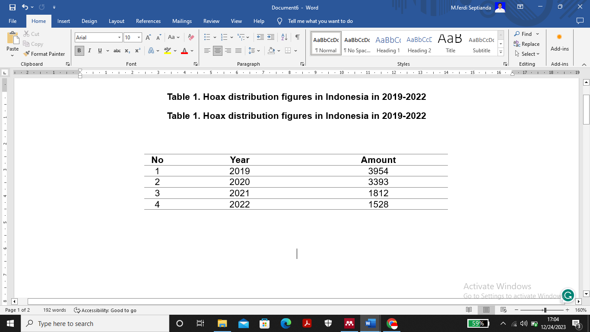**Table 1. Hoax distribution figures in Indonesia in 2019-2022**

Source: Ministry of Communication and Information (2023)

Table 1 shows the number of hoax spreads in Indonesia from 2019 to 2022. In 2019 the number of hoax spreads reached 3,954 cases. In 2020, the number of hoax spreads decreased to 3,393 cases. Then, in 2021 there was a decrease of 1,812 cases. Furthermore, in 2022 there will again be a decrease of 1,528 cases. If analyzed more deeply, in 2019 the rate of spread of hoaxes in Indonesia was relatively high and at the same time in that year, simultaneous general elections were held to elect the president and vice president, DPR, DPD, Provincial DPRD, and Regency/City DPRD. Almost all things directly related to society will be made into issues and develop into hoaxes to cause upheaval in society, as can be seen in Table 2 below:

**Table 2. Hoax issues that often appear in Indonesia in 2018-2023**

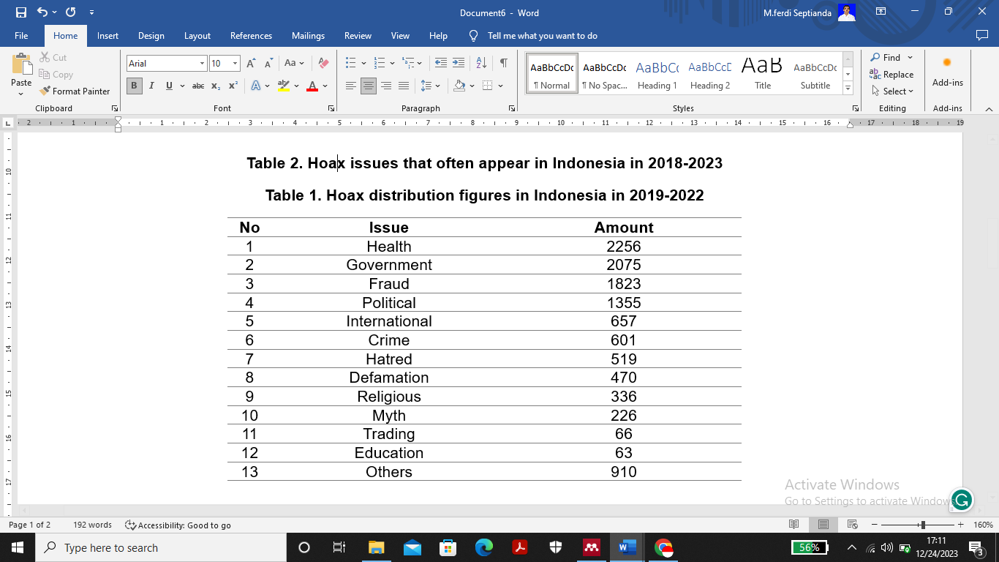

Source: Ministry of Communication and Information (2023)

This Table shows several hoax issues that often arise in people's lives. Health is in first place as something that is often used as a hoax, especially during the Covid-19 era which has caused a lot of disinformation. During that time, many parties whose numbers are difficult to count became victims of hoaxes. The next position is occupied by the government, for various reasons the government is often used as material for political hoaxes. In this case, the government is not always the victim, meaning there are internal factors from within the government. There are many indications that the government itself often creates hoax issues aimed at covering up other problems. the next position is occupied by fraud, followed by politics. Almost every day there is news related to politics whose truth cannot be ascertained.

1. **Digital Literacy Factors**

Digital literacy is very important for every person in society so they can sort out hoaxes and contribute actively to fighting hoaxes (Amaly & Armiah, 2021). Several provinces in Indonesia have quite good digital literacy rates, which can be seen in Table 3 below.

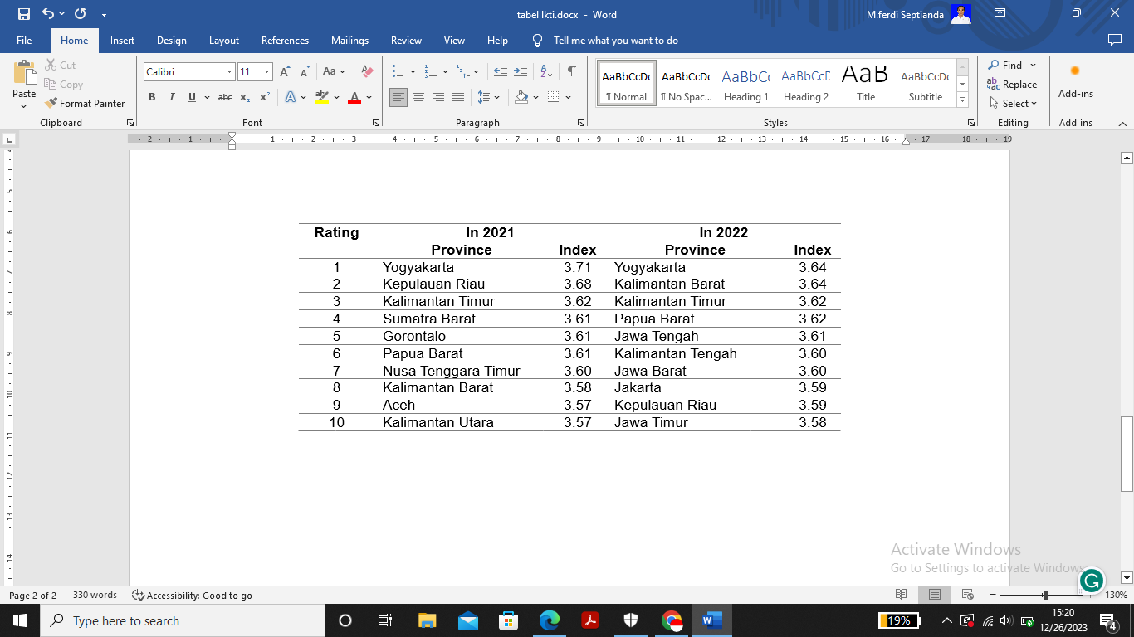**Table 3. Regions with the highest digital literacy index in Indonesia in 2021 and 2022**

Source: Ministry of Communication and Information (2022)

Table 3 shows a comparison of the digital literacy index in Indonesia in 2021 and 2022. In short, it can be seen that in 2021 and 2022 the digital literacy index in Indonesia experienced very significant changes. There will be a changing trend in 2022, only the special regions of Yogyakarta and East Kalimantan are consistent. Provinces such as the Riau Islands and West Papua, which in 2021 were classified as part of the provinces with the best digital index, were also consistently included in 2022, just not at the same level in 2021.

The changes that will occur in 2021 and 2022 want to emphasize the seriousness of the Indonesian government in raising the level of digital literacy in Indonesia, all provinces are competing to find ways to be included in the list of regions with the highest digital literacy index in Indonesia. The survey contains 10 provinces with the highest digital literacy index in Indonesia, while in Indonesia there are 38 provinces. There are still many provinces in Indonesia that have a low digital literacy index and our society is easily fooled by rampant hoax news, especially among teenagers.

**Strategic steps to ward off negative potential during digital campaigns ahead of the Indonesian general election in 2024**

1. **Public Education**

Comprehensive and consistent public education will produce good digital campaigns and form a society that is wise in managing and assessing the truth of information. Regarding public education ahead of the 2024 election, there are two concepts called prebunking and debunking. Prebunking is an anticipatory or preventative action to make the public aware of potential hoaxes or misinformation before it circulates (Lewandowsky & van der Linden, 2021). Meanwhile, debunking is an effort made to uncover lies that have been circulating, aiming to minimize false data that can cause controversy and provocation (Mikha, 2023).

Stephan Lewandowsky et al in the book "The Debunking Handbook 2020" explain that debunking is successful if it fulfills components such as stating the facts first, exploring and pointing out misinformation, explaining in detail why the misinformation is wrong, and finally repeating the facts so that these facts are the last to be understood by people (Lewandowsky et al., 2020). In Indonesia itself, debunking is being intensified by a social organization called "The Indonesian Anti-Defamation Society (Mafindo)". Mafindo is intensively investigating information circulating on social media so that it does not spread further. After further investigation, they will update the results of their findings via social media such as Instagram, X, and Facebook. Mafindo is not only active through online activities but also offline activities.

Mafindo carried out outreach and invited participants who attended to join and become active volunteers fighting hoaxes on social media. Apart from that, in September 2023 Mafindo released a book entitled "Hoaxes in Indonesia in 2022" which contains mapping of hoaxes during the post-pandemic transition as well as ahead of the 2024 elections. Mapping is important for predicting what hoaxes will emerge along with political activities. such as a digital campaign ahead of the 2024 election so that people can be sensitive and think critically about hoaxes. The presence of community organizations like Mafindo should be appreciated and fully supported by the Indonesian government and society. For this reason, the Government can provide public education regarding digital campaigns ahead of the 2024 election by developing more optimal debunking.

1. **Increasing Digital Literacy**

Digital media has a very significant role in people's behavior in the current era of digitalization. In the current era, humans cannot be separated from digital media, almost all activities are carried out via the internet, from young people to old people. Likewise in the case of general elections. According to Rogers, the role of mass media remains very important in the campaign, because the main target of the campaign is the people (Siti Maryam, Pandu Prasetyo, 2021). The presence of digital media will certainly make it easier for someone to carry out campaigns for many people efficiently. Sirajul Fuad Zis et al in Satwika Magazine 2021, said that Generation Z responds to digital devices more quickly than the millennial generation, even without studying and being taught, Generation Z can still play them (Beniman et al., 2022). Indeed, we cannot deny that the times are developing very rapidly in all aspects of life.

Now, many children under the age of five already know and can operate gadgets including social media. Of course, this has its impact on the younger generation in using digital media. In this case, novice voters are relatively more vulnerable to various propaganda carried out by irresponsible parties. They often get political content directly from political actors or candidates via social media. Actions and efforts that can be taken to overcome hoax news, and black campaigns are by increasing media literacy (Dewanti, 2022). This digital literacy aims to provide the public with an understanding of digital media such as social media. Digital literacy is one of the appropriate and effective steps in information control procedures and actions that indicate false and misleading information (Nugroho et al., 2022). There are eight important elements in digital literacy put forward by Belshaw (Tsaniyah & Juliana, 2019), namely culture, thinking, constructiveness, communication skills, self-confidence, creativity, critical, and community support

1. **Supervision and Law Enforcement**

The institution that carries out supervision during the election period is the task of the Election Supervisory Agency (Bawaslu). The state needs supervision over the implementation of a democratic state with guaranteed checks and balances (Sabrina, 2019). Bawaslu itself is aware of the difficulties in carrying out supervision, especially on social media due to the large number of fake accounts being born (Wildianti, 2018). In monitoring to prevent injustice and fraud in elections, the role of the public and the media is very important and determining in supervision (Umar, 2018). The public can report any criminal acts in the election to Bawaslu, which will then be processed by Bawaslu.

In addressing election issues, the Indonesian government has established several regulations in the form of statutory regulations. Law of the Republic of Indonesia no. 7 of 2017 regulations that specifically discuss general elections as a replacement for previous laws. However, these regulations are not enough to overcome election problems. As time goes by, issues regarding elections are becoming more complex. This cannot be separated from the criminal act of organizing digital campaigns that contain hoaxes, hate speech and black campaigns.

The Ministry of Communication and Information also has an important role in supervising election activities, especially monitoring social media related to hoax news. The legal rules governing hoax news are contained in Law Number 11 of 2008 concerning Information and Electronic Transactions which has now been amended by Law Number 19 of 2016 which clearly explains every person who deliberately and without right spreads false and misleading news that Causes consumer losses in electronic transactions can be punished according to Article 28 Paragraph 1 and Article 45A Paragraph 1. Even though this law has been introduced, there are still many acts of spreading hoax news, especially during elections.

As an effort to ward off fake news, the government should provide the public with an understanding of the dangers of hoaxes because there are still many people who have difficulty distinguishing valid information from hoaxes. After all, the lack of socialization regarding campaigns on electronic media makes the campaigns carried out less effective (Farhiyah, 2023).

1. **Inter-Institutional Cooperation**

The institution that has the main task of making elections successful in Indonesia is the general election organizing institution, which means a state institution designed to have a more effective check and balance function than other state institutions (Hananto Widodo & Dicky Eko Prasetio, 2021). This institution contains the General Election Commission (KPU), the Election Supervisory Body (Bawaslu), and the Election Organizer Honorary Council (DKPP). In general, these three institutions were created to create quality democracy by providing mutual control over each other. The KPU is tasked with carrying out all stages, Bawaslu is tasked with supervising all stages of implementation, and DKPP has a special task only related to handling violations of the code of ethics in organizing elections (Yasin, 2022).

It was emphasized that Bawaslu was tasked with supervising all stages of election implementation. In this case, Bawaslu's authority is very strong because all monitoring results containing suggestions and recommendations must be responded to and followed up by the KPU. The KPU can be reported to DKPP for alleged violations of the code of ethics if recommendations from Bawaslu are not followed up by the KPU (Hananto Widodo & Dicky Eko Prasetio, 2021). Focusing on Bawaslu's supervision of campaign activities carried out by Candidates, Political Parties (Parpol), and winning teams ahead of the election, Bawaslu carries out supervision of both offline and online campaigns, however, the supervision carried out by Bawaslu will be very limited because Indonesia is so vast and those supervised are very large. many (Banurea, 2023).

Bawaslu can collaborate with related institutions that have main tasks and functions (Tupoksi) related to efforts to ward off negative potential in the form of hoaxes, hate speech, and black campaigns so that the 2024 elections will be far from conflicts that damage democracy in Indonesia. Apart from looking at the main duties and functions of an institution, it is necessary to analyze and consider the extent to which the institutions that want to be collaborated with in terms of supervision can contribute and actively participate in efforts to increase digital literacy, public education, as well as supervision and law enforcement.

First, in efforts to increase digital literacy, the Indonesian government can maximize it through the Ministry of Communication and Information Technology (Kominfo) and the Ministry of Education, Culture, Research and Technology (Kemendikbudristek) to develop various digital literacy programs that indirectly alert the Indonesian people about the dangers of hoaxes, hate speech, and black campaigns. These efforts have been carried out through various programs, but have not been effective because the education level of the Indonesian people is still dominated by elementary school (SD) graduates, so they are easily exposed to hoaxes, hate speech, and black campaigns. It is necessary to present new programs that target elementary school graduates effectively.

Second, public education regarding countering hoaxes, hate speech, and black campaigns during digital campaigns ahead of the 2024 election can be carried out by the General Election Commission, Election Supervisory Body, law enforcement officials, community leaders, community organizations, public figures, and others. third, in monitoring and law enforcement efforts there must be both preventive and repressive efforts. The government can maximize this through the Republic of Indonesia Police (Polri) which has the authority so that the actions taken can have a deterrent effect and indirectly provide warnings to other communities.

**CONCLUSIONS AND RECOMMENDATIONS**

Researchers analyzed to find out what factors underlie the emergence of negative potential in the form of hoaxes, hate speech, and black campaigns during digital campaigns leading up to the election. Five factors were found that underlie this negative potential. First, is the ambition for power factor. Election participants continue to increase every year, which reflects a strong drive for power. They try to win elections by influencing the legislative process through various campaign strategies, often exploiting issues of religion, culture, and political identity. Second, is the political polarization factor. Candidates' ideas tend to reflect pluralism or religion, with efforts to build support from various groups.

Third, Community and Cultural factors. Globalization influences culture by acculturating foreign elements, but does not erase social cultural values ​​such as cohesiveness and collective support in society. However, globalization also allows negative culture to emerge, especially in digital campaigns leading up to elections, with the spread of hoaxes, hate speech, and other negative practices that are considered normal for society. Fourth, is the digital literacy factor. People are vulnerable to hoaxes because they are often fixated on one source of information and have insufficient digital literacy.

These factors were then analyzed to find strategic steps to counteract the negative potential of digital campaigns ahead of the 2024 elections. Based on the analysis of these fourth factors, four strategic steps were found that the government and society could take to counteract negative potentials such as hoaxes, hate speech, and black campaigns. :

First, public education. Education is not only emphasized in the academic environment but also extends to the general public by focusing on two concepts, namely prebunking (preventing hoaxes) and debunking (dismantling hoaxes). Comprehensive and consistent public education is needed to form a society that is wise in managing and assessing information.

Second, increasing digital literacy, including understanding social media and critical skills. Strong digital literacy will help people to identify false information and propaganda, thereby minimizing their negative impact.

Third, supervision and law enforcement. Bawaslu carries out election supervision with awareness of the difficulties in monitoring social media which is full of fake accounts. Even though there are election regulations, current developments have brought complexity, especially regarding digital campaigns with hoaxes, hate speech, and black campaigns. This should be a matter of greater attention for the government to establish good supervision and law enforcement.

Fourth, cooperation between institutions, and the Government can increase digital literacy through Kominfo and the Ministry of Education and Culture. Public education can be carried out by various institutions and held not only in academic environments but can be carried out in various places containing the wider community. Supervision and law enforcement must be given attention, the National Police can maximize its full authority in preventing and dealing with hoaxes and hate speech with effective action and providing advice to the public

# **REFERENCES**

Abidin, S., & Cindoswari, A. R. (2019). Political Branding Ridwan Kamil Pada Masa Kampanye Pilgub Jawa Barat 2018 Melalui Twitter. *Commed : Jurnal Komunikasi Dan Media*, *4*(1), 33–48. https://doi.org/10.33884/commed.v4i1.1439

Adlini, M. N., Dinda, A. H., Yulinda, S., Chotimah, O., & Merliyana, S. J. (2022). Metode Penelitian Kualitatif Studi Pustaka. *Edumaspul: Jurnal Pendidikan*, *6*(1), 974–980. https://doi.org/10.33487/edumaspul.v6i1.3394

Amaly, N., & Armiah, A. (2021). Peran Kompetensi Literasi Digital Terhadap Konten Hoaks dalam Media Sosial. *Alhadharah: Jurnal Ilmu Dakwah*, *20*(2), 43. https://doi.org/10.18592/alhadharah.v20i2.6019

Andi Muh. Dzul Fadli, Indrawan Tobarasi, K. R. (2018). Kemenangan Petahana Dalam Kontestasi Pilkada Serentak 2018: Ditinjau Dari Perspektif Powercube. *Jurnal TAPIS*, *14*(02). https://doi.org/http://dx.doi.org/10.24042/tps.v14i2.3169

Angretnowati, Y., & Karolus, M. L. (2022). Negara, Gerakan Islam Pasca-Fundamentalis dan Masa Depan Demokrasi di Indonesia: Kekuasaan Simbolik dan Upaya Konsolidasi. *Politika: Jurnal Ilmu Politik*, *13*(2), 369–393. https://doi.org/10.14710/politika.13.2.2022.369-393

Annas, F. B., Petranto, H. N., & Pramayoga, A. A. (2019). Opini Publik Dalam Polarisasi Politik Di Media Sosial Public Opinion Of Political Polarization On Social Media. *Jurnal PIKOM (Penelitian Komunikasi Dan Pembangunan)*, *20*(2), 111.

Banurea, O. K. (2023). *Mediation : Journal Of Law Efektivitas Pengawasan Kampanye Berbasis Digital ( Pencegahan Pelanggaran Praktek Kampanye Berbasis Digital ) Corresponding Author : PENDAHULUAN Kampanye adalah kegiatan peserta pemilu atau pihak lain yang ditunjuk oleh peserta* . *2*, 59–77.

Beniman, Mursin, Ikbar, & Parisu, C. Z. L. (2022). Pemilih Pemula dalam Pemilu 2024. *JSES: Jurnal Sultra Elementary School*, *3*(2), 70–83. https://doi.org/https://doi.org/10.1234/jses.v3i2.90

Boestam, A. B., Prakosa, A., & Avianto, B. N. (2023). Upaya Partai Politik Dalam Memanfaatkan Demokrasi Virtual Di Era Digital. *Jurnal Pustaka Komunikasi*, *6*(1), 1–17. https://doi.org/10.32509/pustakom.v6i1.2281

Danuri, M. (2019). Development and transformation of digital technology. *Infokam*, *XV*(II), 116–123.

Darmalaksana, W. (2020). Metode Penelitian Kualitatif Studi Pustaka dan Studi Lapangan. *Pre-Print Digital Library UIN Sunan Gunung Djati Bandung*, 1–6.

Dewanti, I. N. (2022). Black Campaign Social Media sebagai Komunikasi Aktor Politik dalam Pemilihan Umum di Indonesia. *Jurnal Lensa Mutiara Komunikasi*, *6*(1), 98–105. https://doi.org/10.51544/jlmk.v6i1.2845

Diniyanto, A., & Sutrisno, W. (2022). Pengawasan Pemilihan Umum di Era Post-Truth: Problem, Tantangan, dan Strategi. *Jurnal Adhyasta Pemilu*, *5*(1), 44–58. https://doi.org/10.55108/jap.v5i1.79

Doly, D. (2020). Penegakan Hukum Kampanye Hitam (Black Campaign) Di Media Sosial: Pembelajaran Pemilihan Umum Presiden Tahun 2019. *Kajian*, *25*(1), 1–18.

Fadhilah, J., Layyinna, C. A. A., Khatami, R., & Fitroh, F. (2021). Pemanfaatan Teknologi Digital Wallet Sebagai Solusi Alternatif Pembayaran Modern: Literature Review. *Journal of Computer Science and Engineering (JCSE)*, *2*(2), 89–97. https://doi.org/10.36596/jcse.v2i2.219

Farhiyah, K. S. (2023). Penegakan Hukum Kampanye Politik Media Elektronik Pilkada Kota Pekalongan. *Manabia Journal of Consitutional Law*, *3*(1), 71–106.

Fathurochman, N. Y., & Tutiasri, R. P. (2023). Penerimaan Generasi Z terhadap Polarisasi Politik. *JIIP - Jurnal Ilmiah Ilmu Pendidikan*, *6*(9), 6837–6845. https://doi.org/10.54371/jiip.v6i9.2833

Fensi, F. (2018). FENOMENA HOAX: Tantangan terhadap Idealisme Media & Etika Bermedia. *Bricolage : Jurnal Magister Ilmu Komunikasi*, *4*(02), 133. https://doi.org/10.30813/bricolage.v4i02.1657

Fernando, Z. J., Pratiwi, W., Perdana, P., & Saifulloh, A. (2022). Prosiding Seminar Nasional Program Doktor Ilmu Hukum Ums 2022 Model Penanaman Nilai-Nilai Pancasila Dalam Menghadapi Ancaman Polarisasi Politik Pemilu 2024 Di Indonesia. *Prosiding Seminar Nasional Program Doktor Ilmu Hukum Ums 2022*, 120132.

Gunawan, H. (2021). Nilai etika dalam tatanan globalisasi dan digitalisasi budaya. *Jurnal Sosial Dan Sains*, *1*(7), 645–653. https://doi.org/10.59188/jurnalsosains.v1i7.111

Hananto Widodo, & Dicky Eko Prasetio. (2021). Penataan Kewenangan KPU dan Bawaslu dalam Melakukan Pengawasan dan Menangani Sengketa Proses Pemilu. *Perspektif Hukum*, *21*(2), 200–221. https://doi.org/10.30649/ph.v21i2.93

Haquri, D. D., & Sahab, A. (2023). Perempuan dalam Politik: Rekrutmen Anggota Legislatif Perempuan Partai Demokrasi Indonesia Perjuangan (PDIP) Jawa Timur di Pileg 2019. *Jurnal Politik Indonesia (Indonesian Journal of Politics)*, *9*(1), 69–80. https://doi.org/10.20473/jpi.v9i1.45342

Harahap, N. (2020). Metodologi Penelitian Kualitatif. In *Wal ashri Publishing* (Vol. 59, Issue 1). Wal ashri Publishing.

Irhamdhika, G. (2022). Mitigasi Hoax Di Era Disrupsi Melalui Literasi Digital. *J-Ika*, *9*(1), 39–46. https://doi.org/10.31294/kom.v9i1.12610

Juditha, C. (2019). Buzzer di Media Sosial Pada Pilkada dan Pemilu Indonesia Buzzer in Social Media in Local Elections and Indonesian Elections. *Prosiding Seminar Nasional Komunikasi Dan Informatika*, *3*, 199–212. https://jurnal.kominfo.go.id/index.php/snki/article/view/2557/1255

Kurniasih, E. (2019). Media Digital pada Anak Usia Dini. *Jurnal Kreatif*, *9*(2), 87–91.

Lewandowsky, S., Cook, John Ecker, U., & Albarracín, D. K. P. (2020). *The Debunking Handbook 2020*.

Lewandowsky, S., & van der Linden, S. (2021). Countering Misinformation and Fake News Through Inoculation and Prebunking. *European Review of Social Psychology*, *32*(2), 348–384. https://doi.org/10.1080/10463283.2021.1876983

Mansyur, I. C. (2023). Polarisasi Politik di Indonesia 2014-2019: Sebuah Kajian Pustaka. *Jurnal Politik Profetik*, *11*(1), 1–22. https://doi.org/10.24252/profetik.v11i1a1

Mikha. (2023). hoax dan fenomena kebebasan berpendapat di zaman homo digitalis. *Jurnal Komunikasi*, *1*(1), 31–41.

Mulyani, R. (2021). Political Branding Tsamara Amany Alatas Selama Masa Kampanye Pemilu Legislatif 2019 di Media Sosial. *LUGAS Jurnal Komunikasi*, *5*(1), 21–30. https://doi.org/10.31334/lugas.v5i1.1554

Nahak, H. M. . (2019). Upaya Melestarikan Budaya Indonesia Di Era Globalisasi. *Jurnal Sosiologi Nusantara*, *5*(1), 65–76. https://doi.org/10.33369/jsn.5.1.65-76

Naomi, E. E., & Muhyidin, A. (2021). Faktor-Faktor Ambisi Politik Imigran Korea Utara di Korea Selatan (Studi Kasus: Keterlibatan Thae Yong-Ho dan Ji Seong-Ho sebagai Kandidat dalam Kontestasi Pemilu Legislatif di Korea Selatan Tahun 2020). *Jurnal Ilmiah Ilmu Sosial*, *7*(1), 67. https://doi.org/10.23887/jiis.v7i1.33131

Nugroho, A. S., Hidayat, N., Robiyanti, R. R., & Purwaningsih, T. (2022). Peran Literasi Digital Dan Big Data Dalam Mencegah Hoax Jelang Pemilu 2024. *Media Informasi Penelitian Kabupaten Semarang(SINOV)*, *4*(2), 98–105.

Putra, R. A. (2018). Peran Teknologi Digital dalam Perkembangan Dunia Perancangan Arsitektur. *Elkawnie*, *4*(1), 67–78. https://doi.org/10.22373/ekw.v4i1.2959

Sabrina, A. R. (2019). Literasi Digital Sebagai Upaya Preventif Menanggulangi Hoax. *Communicare : Journal of Communication Studies*, *5*(2), 31. https://doi.org/10.37535/101005220183

Salim, Z. (2018). Hoax Dan Perilaku Masyarakat Menjelang Pilpres Dan Pileg 2019. *THC Review*, *5*, 33–43.

Saodah, Amini, Q., Rizkyah, K., Nuralviah, S., & Urfany, N. (2020). Pengaruh Globalisasi Terhadap Siswa Sekolah Dasar. *Jurnal Pendidikan Dan Dakwah*, *2*(3), 375–385. https://ejournal.stitpn.ac.id/index.php/pandawa

Siahaan, H. E. R. (2018). Aktualisasi Pelayanan Karunia di Era Digital. *EPIGRAPHE: Jurnal Teologi Dan Pelayanan Kristiani*, *1*(1), 23. https://doi.org/10.33991/epigraphe.v1i1.7

Siti Maryam, Pandu Prasetyo, V. M. (2021). Literasi Media Digital Pada Kampanye Greenpeace Id Di Media Sosial Instagram Dalam Merubah Perilaku Masyarakat. *Jurnal IKRA-ITH Humaniora*, *5*(1), 242–253.

Susanti, S., Gunawan, W., & Koswara, I. (2023). Pemanfaatan Media Sosial dalam Mengembangkan Pemasaran Batik Sukapura. *Jurnal Pengabdian Pada Masyarakat*, *8*(1), 95–104. https://doi.org/10.30653/jppm.v8i1.215

Tahmidaten, L., & Krismanto, W. (2020). Permasalahan Budaya Membaca di Indonesia (Studi Pustaka Tentang Problematika & Solusinya). *Scholaria: Jurnal Pendidikan Dan Kebudayaan*, *10*(1), 22–33. https://doi.org/10.24246/j.js.2020.v10.i1.p22-33

Thr/bmw. (2023). *Ganjar soal Siaran Azan: Saya Tak Punya Sejarah Politik Identitas*. CNN Indonesia.

Tsaniyah, N., & Juliana, K. A. (2019). Literasi Digital Sebagai Upaya Menangkal Hoaks Di Era Disrupsi. *Al-Balagh : Jurnal Dakwah Dan Komunikasi*, *4*(1), 121–140. https://doi.org/10.22515/balagh.v4i1.1555

Umar, M. (2018). Cegah Pemilu Tidak Adil dan Curang. *Jurnal BAWASLU DKI Jakarta*, 15–20.

Wahyu Permadi, S., & Bahri, S. (2022). Tinjauan Yuridis Penagihan Hutang Dengan Penyebaran Data Diri Di Media Sosial. *Jurnal Hukum Ius Quia Iustum*, *29*(1), 24–46. https://doi.org/10.20885/iustum.vol29.iss1.art2

Widiyono, S. (2019). Pengembangan Nasionalisme Generasi Muda di Era Globalisasi. *Jurnal Populika*, *7*(1), 12–21. https://ejournal.widyamataram.ac.id/index.php/populika/article/view/24/21

Wiguna, W. (2017). Media Sosial dan Komunikasi Politik Era Digital. *Jurnal Komunikasi Indonesia*, *3*(2), 1–4. https://doi.org/10.7454/jki.v3i2.8849

Wildianti, A. P. dan D. (2018). Narasi Kampanye dan Media Sosial dalam Pemilu Presiden dan Wakil Presiden Tahun 2019. *JURNAL PENGAWASAN PEMILU Provinsi DKI Jakarta*, 19–37.

Yasin, R. (2022). Hak Konstitusional Warga Negara Dalam Pemilu. *Bawaslu Provinsi Kepulauan Riau*, *4*(2), 186–199.