|  |  |
| --- | --- |
|  | **Available online at** <https://ojs.umrah.ac.id/index.php/kemudi>  Volume: 8 (2) Issue: 26 Febuary 2024  **KEMUDI: JOURNAL OF GOVERNMENT SCIENCE ISSN (Online): 2622 9633, ISSN (Print): 2528 5580** |

The Degradation of Meritocratic Democracy: Political Determination of Gibran Rakabuming's Nomination Dynasty in the 2020 Solo Regional Head Elections

Putri Hergianasari 1, Diana S.A.N Tabun 2, Semuel Risal3

1International Relation, Universitas Kristen Satya Wacana, Salatiga

2Jurusan Ilmu Politik, Universitas Nusa Cendana

3STIA Bina Banua, Banjarmasin

*Corresponding Author:* [*putri.hergianasari@uksw.edu*](mailto:putri.hergianasari@uksw.edu)

|  |  |
| --- | --- |
| **Article Info** |  |
| **Keyword:**  Democracy, Meritocratic,  Political Dynasty, Local Election; | **Abstract:** This paper discusses the erosion of the meritocratic system in the victory of Gibran, Jokowi's son, who does not yet have sufficient political experience but advanced and won in the 2020 Solo regional head election by PDIP Party. The research aims to analyze the merit system in Gibran's candidacy and the embryonic political dynasty that Jokowi is trying to build. This study used descriptive qualitative method. data sources were obtained from literature and online data searches. This research uses the theory of Meritocracy Stephen J. McNamee and the concept of a political dynasty. This research results that the degradation of democracy comes from the inconsistency of Gibran's speech and behavior, this is a problem of political ethics. Gibran's advancement in the 2020 Solo contest shows the degradation of democracy in the institutional structure of the PDIP party because the phenomenon of Gibran's candidacy ignores meritocracy. The correlation between political parties, prospective candidates and constituents must be based on a merit system. In conclusion, Gibran's victory in the 2020 Solo Mayoral Election ignores meritocracy and is a degradation of democracy. The correlation between political parties, candidates and constituents is a mutually influential relationship to the practice of merit which is the basis for political contestation. |
|  |  |
| **Article History:** Received 22-07-2022, Revised 17-11-2023, Accepted: 26-01-2024 | |
| **How to Cite:**  Hergianasari et al. (2024). The Degradation of Meritocratic Democracy: Political Determination of Gibran Rakabuming’s Nomination Dynasty in the 2020 Solo Regional Head Elections. KEMUDI: Journal of Government Science, 8(02), 114-127. | |
|  | |

**INTRODUCTION**

Article One of the serious problems after the 1998 reformation was to correlate the dynamics of democratic politics with meritocratic principles. This challenge is very visible when local electoral political contests which actually provide space and accessibility to all citizens (inclusive) are not only objects but political subjects are still bumped into by the walls of political clientelism (patron-client) based on patterns and relationships. kinship (dynastic politics) which negates the principle of meritocracy. Local election philosophy which consists of local democratic political dialectic that is intertwined with the ideas and demands of local citizens become contaminated by strong politics in oligarchic and capitalist networks. It is this political phenomenon that explains the degradation of democracy in the Solo elections on December 9, 2020 (kompas.com, 2019)

President Joko Widodo's son, Gibran Rakabuming Raka, won the 2020 Solo Regional Head Election. Gibran Rakabuming Raka and Teguh Prakosa were promoted by PDIP party as a pair for Mayor and Deputy Mayor of Solo 2020-2025 against Bagyo Wahono-FX Suparjo. The Gibran-Teguh pair won with 87.15% of the votes compared to Baygo-Supardjo's 12.85% of the votes. Details of the votes are as follows:

**Table 1.**

**Details of 2020 Solo Regional Elections**

**No Information Nominal**

|  |  |  |
| --- | --- | --- |
| 1 | Gibran-Teguh | 225.451 |
| 2 | Bagyo-Wahyono | 35.055 |
| 3 | Jumlah Suara Sah | 260.506 |
| 4 | Jumlah Suara Tidak Sah | 35.476 |

**Total 100%**

Source: (KPU Surakarta, 2020)

The data in the table shows that the Gibran-Teguh pair got 22.5,451 votes, which outperformed Baygo-Wahyono's votes by a difference of 190,396 votes. Gibran who is Jokowi's eldest son is involved in various culinary businesses and start-ups including Markobar, Chilli Pari, Pasta Buntel, Chakar Dheer, Mangkokku, for businesses other than culinary, namely PT Rakabu Sejahtera, Boss State Tasks, Hompimpa Games, Workholic, but does not have political background. The first research question is the phenomenon of Gibran's candidacy in the Solo Mayoral Election for the 2020-2025 period is based on a merit system? second. how did political dynasties beat meritocracy in Gibran's candidacy?

**Literature review**

Studies and research related to the practice of non-merit systems in elections, cadre of political contestants so that they have the potential to create a political dynasty are also found in research entitled “Political Analysis of Dynasties in Kediri Regency”. This study explains that the practice of dynastic politics has been running for almost 20 years. The study explains that the political dynasty in Kediri was initially formed from business affairs and then continued to political affairs. The research discusses how to maintain power by building a political dynasty, then developing it in the midst of the ups and downs of democracy. (Bimantara, 2018) An article in a scientific journal entitled “Political Dynasty in Local Election in Indonesia” explains that oligarchs in political parties can be analyzed on the tendency of nominating candidates by political parties which are more based on the wishes of political party elites and not through a democratic mechanism, namely by considering integrity and abilities of the candidate. (Susanti, 2018) The article with the title “Local Election, Dynasty Politics, and Corruption” explains that there is a correlation between dynastic politics and corrupt practices. Kinship in politics and government can influence decisions or policies made with the aim of personal or group interests.(Suharto et al., 2017).

A journal article with the title “Political Dynasty on President Jokowi's Leadership Due to Local Political Contest”, Gibran-Bobby explained that Jokowi's power can influence the process of local political contestation. This is reflected in the victory of Gibran and Bobby in the 2020 regional elections (Suryatwan, 2020). The journal article entitled “The Rise of Political Dynasties in Decentralized Indonesia” explains that there are three factors that contribute to the rise of regional political dynasties in Indonesia, namely the weakness of party institutions, the weak implementation of the Election Law, and the personalistic mindset of voters in the election of leaders.(Kenawas., 2013). This study tries to analyze the degradation of meritocratic democracy in the political determination of the nominating dynasty of Gibran Rakabuming in the 2020 Solo Local Election by analyzing three important roles in the local election, namely political parties, candidates/candidates and constituents.

**Meritocracy**

Michael Young is the figure who first coined the idea of ​​meritocracy, He wrote a book entitled “Rise of the Meritocracy in 1958”. The definition of meritocracy is the process of recruiting government officials based on their capabilities in carrying out their duties and not based on political connections. (Young, 1994) Stephen J McNamee in his book entitled “The Meritocracy Myth” states that meritocracy is a system that emphasizes the appropriateness or worthiness of a person to occupy a certain position or position. Appropriateness here is defined as ability regardless of their ethnic background, political affiliation, or social status. The merit system is a system that gives more rewards to someone who excels.(Han & goleman, daniel; boyatzis, Richard; Mckee, 2019). The parameters used in the consideration for the appointment, approval and selection of the recruitment of public officials are competence, capability, integrity, professionalism and acceptability.

The characteristics of the merit system are as follows: First, having adequate achievements and abilities so that it can be used to occupy a position or position in the government. Second, give awards to someone who excels. An example of a country that implements a merit system is Singapore. In the general election in Singapore, competence is used by constituents to make choices, so as to prevent the majority power from dominating. China also implements a meritocracy to maintain the stability of a country consisting of various ethnicities and cultures. Meritocracy occurred in Indonesia during the Sjahrir Cabinet where all opportunities in the ministry were filled by people who had the capability. Meritocracy is a recruitment system that is not based on patrimonial relations, kinship, regional similarities, group similarities and religious similarities, but is based on the skills and abilities of the person concerned. So that the merit system can make people become professionals in carrying out them duties and responsibilities as well as in establishing cooperation. What about the cadre of political parties, namely PDIP party over Gibran, did they use the merit system as a parameter, and did the people in choosing Gibran also use the merit system parameters?

**Political Dynasty**

The definition of a political dynasty is referring to the situation where in members of the same family are occupying elected either in sequence for the same position or simultaneously by across different positions.(Mendoza et al., 2013). Political dynasty is political power exercised by a group of people who have family ties or relatives. Political service is usually closely related to the royal system, in which a king will bequeath his throne to the heir, namely his son with the aim that this power remains within his family circle. Political dynasty refers to the situation in which members of the same family occupy elected positions either successively for the same position or simultaneously in various positions.

Previously in the Suharto era, political dynasties were appointed directly, and post reformation through procedural political channels, by means of which children or families were prepared through political parties. Things that can give rise to political dynasties, among others, are the first, the desire of the political elite in power to continue to perpetuate their power by passing on that power to their children or families. Second, there is a group of political elites who have agreed to form group rulers and group followers. Third, there is cooperation between the ruling political elite and businessmen to combine political power with capital power. The public has the same opportunity in politics, this is guaranteed in the 1945 Constitution which states that "political rights are part of human rights". The right to be elected expressly is regulated in the 1945 Constitution starting with Article 27 paragraphs (1) and (2); Article 28, Article 28D paragraph (3), Article 28E paragraph (3). In the case of the nomination for the Regional Head Election, this arrangement emphasizes that the state must fulfill the human rights of every citizen, especially in involvement in the government to be elected in a democratic party which includes the General Election, Presidential Election and Regional Head Election.

In Article 2, the implementation of elections is guided by: independent, honest, fair, legal certainty, orderly, public interest, openness, proportionality, professionalism, accountability, efficiency, effectiveness and accessibility. Article 3 contains the requirements for election participants as follows: "Couples of candidates proposed by political parties or coalitions of political parties and have met the requirements to be determined as election participants, and/or pairs of individual candidates who have registered and have met the requirements are determined as election participants." (PKPU 22 Tahun 2018, 2018).

**RESEARCH METHOD**

This This study uses a qualitative descriptive method with data collection using a literature study. This method is used to describe or describe accurately and systematically relevant facts data, and relationships between phenomena being studied. Data were obtained through literature study, namely literature, related documents and news in mass media sourced from credible media. online data searches, data from the Surakarta General Election Commissions and books with the theme of Meritocracy, Political Dynasties and Regional Head Elections.

Data analysis uses the Miles and Huberman technique, namely first collecting data from various sources, second reducing data, that is sorted and selected according to the topic of discussion and then analyzed using merit system theory. Third, the data is presented using a predetermined writing systematic, fourth, drawing conclusions and suggestions.(Miles, Matthew B, Huberman, 1994).

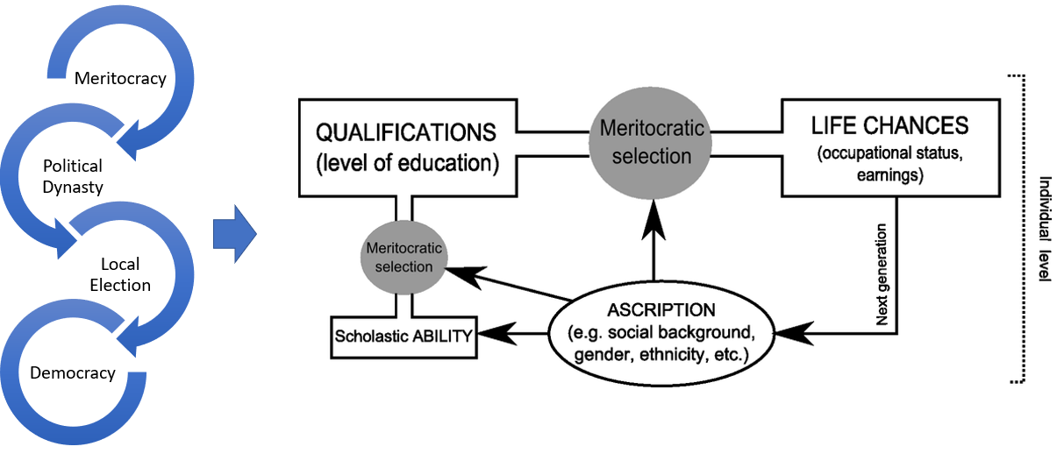

**Figure 1: Theoretical Framework**

**RESULTS AND DISCUSSION**

This President Joko Widodo had a career in politics for the first time, serving as Mayor of Solo in the 2005 regional elections. In 2010 Jokowi was re-elected in the 2010 Solo elections with support from the PDIP party. Gibran took the same path to start a political career. The election of Gibran as Mayor of Solo can be said to have created a new political dynasty in the Jokowi breed. The results of the research, first, the degradation of democracy comes from the inconsistency of Gibran's statement. Gibran Rakabuming's Twitter @chillipari pointed out that in speaking in public spaces, Gibran stated that he was not interested in becoming a politician, either as a party cadre or as a candidate for regional head. The following is evidence of Gibran's statement on Twitter.

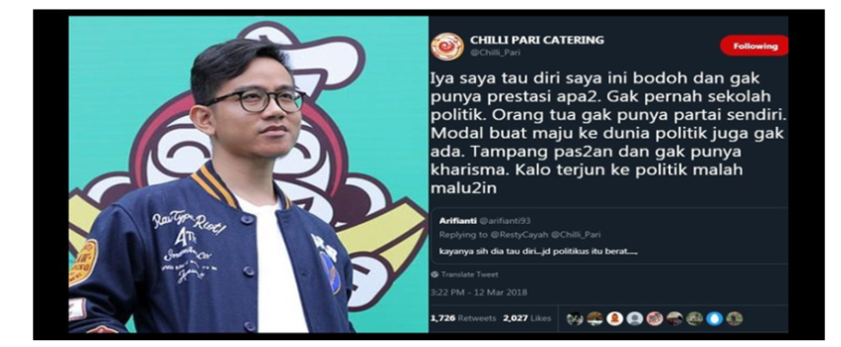

**Figure 2: Gibran's tweet on his Twitter account**

Source: Twitter @chilliparcatering

**First**, if consistent, the statement of the son of a president who is massively active in office, will clearly strengthen democracy in terms of commitment ethics, ethics of openness to the election contestation space that puts forward the principles of competence, integrity and a good track record and avoids the formation of an oligarchic network between economic forces (capitalists). with power (political). However, not long ago, in September 2019, Gibran registered himself as a PDIP cadre as well as running as a candidate for mayor of Solo 2020 and even won the Solo 2020 election. Gibran's statement in his twitter account seemed to refuse to enter the world of politics because he acknowledged that his abilities would affect him. the world of politics is very minimal. This is contrary to the actions he took, namely to run for the Solo Mayor Election for the 2020-2025 period. The written statement on Twitter and the actions he takes are different so that it is an ethical problem in politics.

**Second**, the advancement of Gibran in the 2020 Solo Local Election contestation shows the degradation of democracy in the party institutional structure (PDIP). The Surakarta City PDIP DPC has actually registered Achmad Purnomo and Teguh Prakoso as PDIP party candidates through a deliberation mechanism (bottom-up) in the 2020 Solo Local Election. In fact, F.X. Rudyatmo, the Mayor of Solo and Chairman of the DPC PDIP party Surakarta City brought the file to the PDIP party. Internal friction then arose when Gibran could not register through the PDIP party of Branch Representative Council and received protests from the rejection of the PDIP party cadres for Gibran's political behavior. Gibran's pragmatic political logic was the by-pass route of his candidacy through the Central Java PDIP party, which was later approved by the PDIP party General Chair, Megawati Soekarnoputri. For democracy, Gibran's political practice is a form of injury to the meritocracy-based organizational structure mechanism (merit system).

**Third,** Gibran-Teguh went forward with a puppet opponent, namely Bagyo-Wahyono. This is obtained from data in the form of a book entitled Jokowi's Political Dynasty with field research that has been carried out by the Tirto & Kurawal Foundation. Explained that there were allegations of Identity Card brokering carried out by certain individuals so that Gibran-Teguh did not fight the empty box.(Kurawal Foundation, 2020). The book tells that there was a political broker who collected thousands of Identity Card support for the Bagyo-Wahyono pair on an individual/independent line with the aim of keeping Solo's security "conducive". An oddity was found, namely during field verification, several residents were recorded as supporters of Bagyo Wahyono, but these residents felt that they had never submitted their ID cards and had never filled out a statement of support. The practice of profiteering ID cards to gather mass support can be ensnared by Law No. 10 of 2016 concerning the regional election and if it is proven that there is a falsification of ID cards, then it can be charged with Law No. 24 of 2013 concerning population administration. This is an insult to democracy. The act of justifying various ways in order to continue to advance in political contestation by injuring it, is not in accordance with the merit system parameters, namely competence, capability, integrity, professionalism and acceptability.

**Fourth**, there were 37.8% abstentions at the polling station where Gibran lives, this is one of the impacts of the statement of the Chairman of the PKS party campaigning for abstention in the Solo elections in September 2020 because PKS party does not want to support the Gibran-Teguh pair.

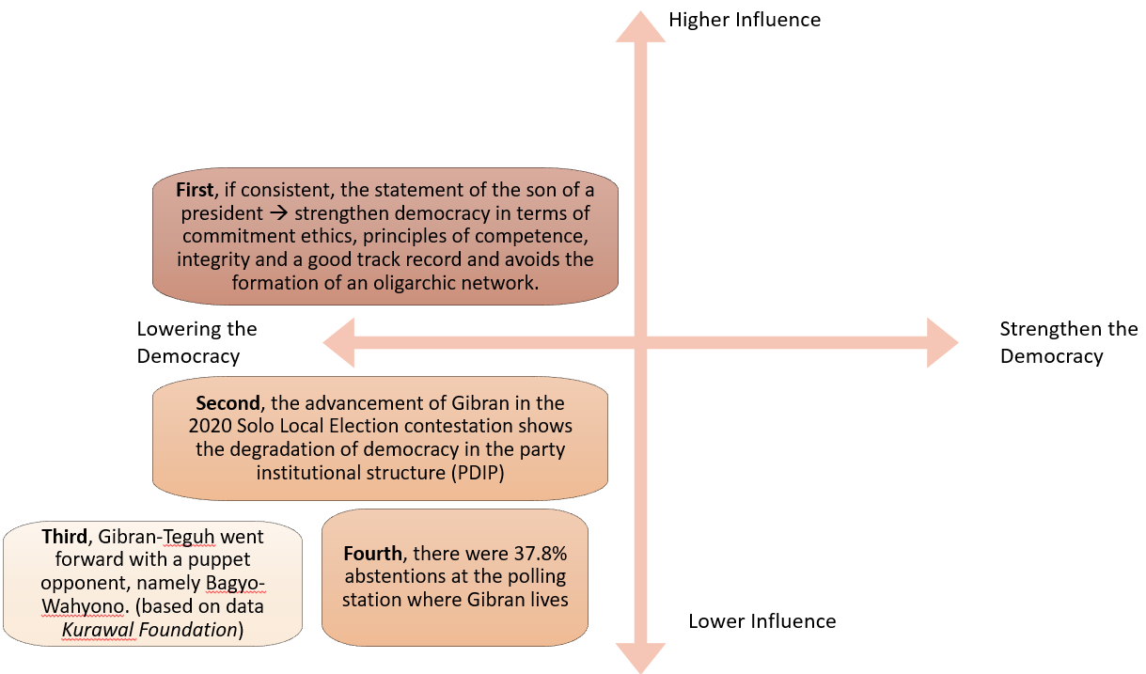

**Figure 3: Level of Analysis**

The emergence of the political dynasty embryo from the analysis of this research is caused by three things, **first**, the regeneration of political parties does not go well in recruiting candidates for regional heads only relying on figures and popularity, political parties are only vehicles for candidates so that there is infertility in the function of political parties in cadre (Hergianasari, 2016). Political parties are one of the important institutions in the development of a representative democratic system in Indonesia besides the General Election Commission. One of the functions of political parties is as a bridge that connects the people with the government, so that the policies made by the government are based on the interests and aspirations of the people. In Indonesia, political parties have a strategic position because they are the only democratic institutions that carry out functions in political recruitment. This is stated in the 1945 Constitution from the results of the amendments that political parties are participants in the legislative elections that play a role in choosing members of the People's Representative Council and Regional People's Representative Council as well as in carrying pairs of candidates in the presidential election, regional head elections, namely the election of governors, regents and mayors along with representatives. Political parties through the People's Representative Council are the ones that play a role in the selection of public positions from members to state leaders.

**Second**, the context of people who are not politically literate but are easily influenced by political issues that develop both on social media and directly is still one of the characteristics of constituents in Indonesia. Indonesia has not succeeded in applying the democratic system that is embraced as a whole in the cultural realm. This is reflected in the local elections and elections in Indonesia, constituents are treated to various political lures, contestants’ campaign for themselves as religious figures, as charismatic role models, as people's tongues. Issues of identity politics are played and used as a campaign tool to arouse people's emotions so that a dichotomy occurs in the supporters of the candidates. Grass root circles with lower secondary education backgrounds, who are generally political clouds and usually work in the informal sector are fertile ground for candidates to spread political promises, identity politics issues, hoax news so that they can weaken the political reasoning power of the community.

**Third**, the electability of prospective candidates, Gibran won in the 2020 Solo Local Election even though he does not have a background in the world of politics. Based on the resultsnof a survey conducted by the National Survey Media research institute (Median), Gibran'snelectability was 19.1%. (kompas.com, 2019). Gibran's strategy in increasing electability is not by increasing scientific capacity and experience related to politics. Gibran and his winning team increase electability by, first, dropping out of the market. Gibran tries to increase electability by going directly to the community, namely *blusukan* at the traditional Nusukan Market, Depok Market, Gading Market, Solo. Second, *blusukan* on social media to win the sympathy of netizens by making the hashtags *#kancanegibrangess* and *#kancanegibran* the hashtags contain activities carried out by Gibran. Third, with the social action of the Kancane Gibran Gess (KaGeGe) volunteer, namely carrying out social actions in the form of free medical therapy, gymnastics, mass circumcision. This is done to gain votes, but does not increase the candidate's capability according to the merit system, namely the capabilities and achievements possessed. The following is a picture of the correlation between political parties, prospective candidates and constituents that influence and influence each other.

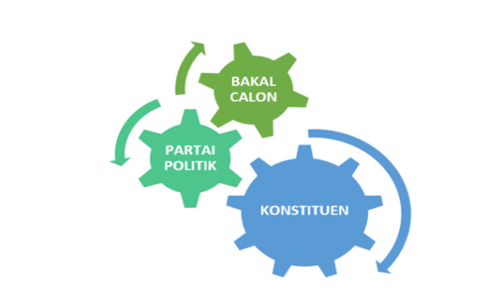

**Figure 4. Correlation between Prospective Candidates, Political Parties and**

**Constituents**

The picture above illustrates that there is mutual influence and influence between political parties, prospective candidates and constituents in the success of a democratic party. It is undeniable that the organizers of the General Election Commissions democratic party also play an important role. This neglect of meritocracy has caused Indonesia's democracy to decline. Because they only want to get the most votes, then there are instant executive and legislative candidates, relying solely on popularity whether it's celebrities, comedians or palace relatives who don't care about track records and don't care about vision and programs, as a result, the opportunity for civil society is closed to obtain candidates for leaders who are reliable. This is the main problem of dynastic politics. The political condition of Indonesia, where the political institutionalization process is still unable to control the style of power in the form of a pledge by the political elite and family to reject dynastic politics, is an ethical commitment of the republic to maintain and change a democratic country. The following is a picture of meritocracy in the correlation of political parties, prospective candidates and constituents.

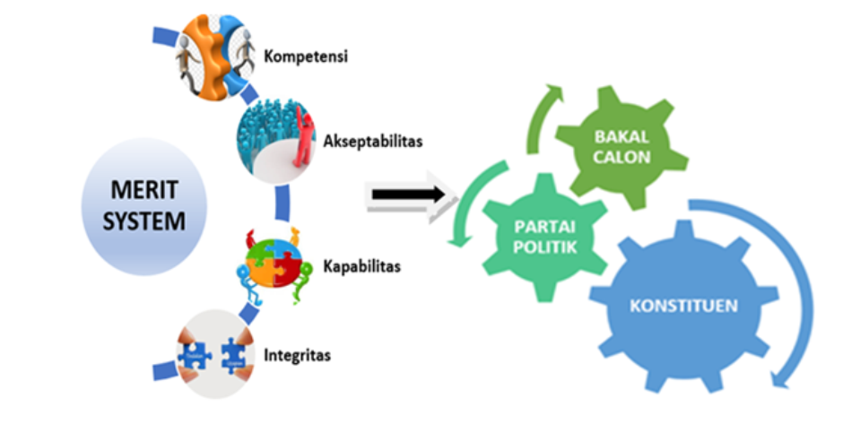

**Figure 5. Meritocracy in Correlation of Political Parties, Prospective Candidates and Constituents**

The picture above illustrates that the parameters of the merit system, namely competence, acceptability, capability and integrity, must be possessed by political parties, prospective candidates and constituents so that they can create a democratic system in political contestation that gives birth to a democratic system at the local and national levels. Political dynasties actually do not violate the law, because all citizens have the same opportunity to participate in politics, and are supported by competent capabilities, but it is the practice of nepotism that ultimately hurts democracy. This is also what Jokowi has done to build a political dynasty with the emergence of Gibran on the stage of democratic contestation in Solo 2020. What is highly emphasized in this research is the capability of Gibran who is a culinary entrepreneur and then transformed into the world of politics. The point is that the political dynasty is not the dynasty itself, but if there is a neglect of leadership criteria and leadership skills, and that is what happened in the Gibran case. Gibran's candidacy, according to researchers, shows that Jokowi is nothing more than an ordinary politician with pragmatism and political calculations, Jokowi's politics like other politicians. This is not wrong, but the image and hope that Jokowi will not only appear as a politician but also a statesman have faded in the phenomenon of Gibran's candidacy. The difference between politicians and statesmen is that politicians only focus on thinking about the future of themselves and their families. Statesmen are concerned with the future of the next generation. One of the things that makes Jokowi special is that he doesn't involve his family's interests in politics. In the midst of a situation where political dynasties have plagued Indonesia, in the midst of symptoms where political parties only act as political machines to pursue power, Jokowi's appearance may raise hopes for improvement.

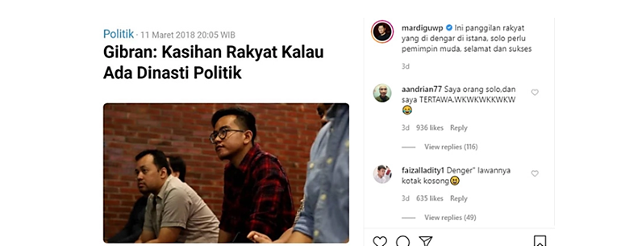

**Figure 6. Gibran's Instagram Regarding Political Dynasty Statements**

From the picture above, it is stated that Gibran does not agree with the existence of a political dynasty. It would still be the opposite of what he did. The comments on Instagram also have pros and cons. So that Gibran's integrity is also questioned. Integrity is consistency between words, actions with strong moral and ethical values ​​and principles. (Menzel, 2014)This is also a violation of political ethics. Violating ethics does not necessarily violate the law, for example, ethics is an association while law is a member of the association. Law is part of ethics. The effect of ethical violations is far more destructive than law violations because ethical violations damage the social capital in the form of trust, which in turn can cause chaos. Jokowi is a failed civil society experiment. Aspects of abuse of power, despotic nepotism. Politicians become statesmen when they dare to maintain ethics in behavior in moments of opportunity. George W turned down the opportunity to be president of the United States again even though the opportunity existed and there was no law he would violate if he took the opportunity, but he chose not to take it because he maintained Republican ethics.

Benedict Anderson in his book entitled Language and Power: Exploring Political Cultures in Indonesia which contains the Concept of Politics and Power in Java. In his argument he states that Javanese power does not require legitimacy, power is power. This legitimacy is actually an ethic that is not only based on the politics of parliamentary approval, but also political ethics. (Anderson, 1990) This means that such an understanding of power does not require ethics. Pancasila should be made to be a political ethic. But none of our politicians dream of being statesmen. Their fantasy is to become a state magnate. Their fantasy is fulfilled by becoming a state official, ethics as a basis for legitimacy to act has been ignored. Because the desire to make their offspring as leaders pass down fantasies to their children.

# **CONCLUSION AND RECOMENDATION**

Presented The emergence of dynastic politics is caused by the stagnation of democracy. This structurally resulted in an overdose of autonomy so that local power emerged in the regions, then from this local power dynasties could grow, while political ethics became low because political education and cadre of political parties did not go well. Meritocracy, allows someone to advance to the highest level and even become president, without having to worry about political considerations. If the people of a country are aware that they can progress because of achievements, they are more likely to do things optimistically in an effort to improve their abilities. Thus, there is no gap that often appears in public opinion that someone close to power (insiders) has the opportunity or someone who is rich has a chance to be successful in his career and work.

The acceptance of meritocracy is based not on what "is" but on the belief that the system of equality is "fair" and that it "works." According to the ideology of meritocracy, equality is seen as "fair" because everyone may have an equal chance of success, and success is determined by individual achievement. Those who are the most talented, who work the hardest, and have experience and track record in politics such as statesmen are the ones who have the right to run for political contests. The correlation between political parties, candidates and constituents is a mutually influential relationship to the practice of merit which is the basis for political contestation.

The suggestion in this article is that the government can make rules/regulations that are related to regulation or prohibition on those who have family kinship not to run for Regional Head Elections or legislative elections with a certain time limit without violating Human Rights which every citizen who does not in legal matters can run for political contestation.

# **REFERENCES**

Anderson, B. (1990). *Language and Power: Exploring Political Cultures in Indonesia - Benedict R. O’G Anderson - Google Books*. Equinox Publishing. https://books.google.co.id/books?id=05cZ6dxZYLcC&printsec=frontcover&source=gbs_ge_summary_r&cad=0#v=onepage&q&f=false

Bimantara, N. (2018). Analisis Politik Dinasti di Kabupaten Kediri. *Jurnal Studi Politik Dan Pemerintahan*, *7*, 201–210.

Han, E. S., & goleman, daniel; boyatzis, Richard; Mckee, A. (2019). The Meritocracy Myth. In *Journal of Chemical Information and Modeling* (Vol. 53, Issue 9).

Hergianasari, P. (2016). Matinya Mesin Partai Politik (Studi Kasus Pencalonan Syahri Mulyo dalam Pilkada Kabupaten Tulungagung. *Jurnal Cakrawala ISSN*, *1693*(2), 6248.

Kenawas., Y. C. (2013). *The rise of political dynasties in decentralized Indonesia.*

kompas.com. (2019). *Elektabilitas di Bawah Purnomo, Pendukung Gibran Beberkan Strategi Kejar Ketertinggalan*. Kompas.Com. https://regional.kompas.com/read/2019/12/17/13394281/elektabilitas-di-bawah-purnomo-pendukung-gibran-beberkan-strategi-kejar

PKPU 22 Tahun 2018, (2018).

KPU Surakarta. (2020). *Lampiran Pengumuman D.Hasil Kab-Kota-KWK.pdf*.

Kurawal Foundation, T. (2020). Dinasti Politik Keluarga Jokowi. In *Kurawal Foundation, Tirto*.

Mendoza, R., Beja Jr, E., Venida, V., & Yap, D. (2013). Political dynasties and poverty: Resolving the “chicken or the egg” question. *MPRA Paper*.

Menzel, D. C. (2014). Ethics Management for Public Administrators. In *Ethics Management for Public Administrators*. https://doi.org/10.4324/9781315704500

Miles, Matthew B, Huberman, A. M. (1994). Qualitative Data Analysis. In *Sage Publications*.

Suharto, D. G., Dwi, I., Nurhaeni, A., Hapsari, M. I., & Wicaksana, L. (2017). Pilkada, politik dinasti, dan korupsi. *Seminar Nasional Strategi Pembangunan Daerah Kepulauan FISIP UMRAH 2017*, *1983*, 30–49.

Suryatwan, A. (2020). Dinasti Politik Pada Kepemimpinan Presiden Jokowi Akibat Kontestasi Politik Lokal Gibran-Bobby. *Journal Publicuho*, *3*(3), 289. https://doi.org/10.35817/jpu.v3i3.12972

Susanti, M. H. (2018). Dinasti Politik dalam Pilkada di Indonesia. *Journal of Government and Civil Society*, *1*(2), 111. https://doi.org/10.31000/jgcs.v1i2.440

Young, M. (1994). *The Rise of the Meritocracy (Classics in Organization and Management Series)* (p. 200).